Press release: 21 February 2023, for immediate release.

Project Director appointed for Town Hall Cultural Centre and Museum Project.

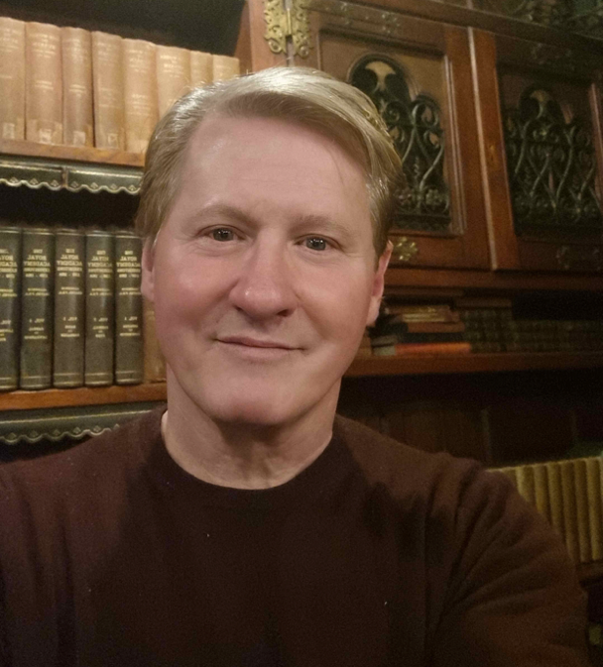
Following the successful application to The National Lottery Heritage Fund and a grant secured for the Town Hall Cultural Centre and Museum project, the Council are pleased to appoint Neil Richardson as Project Director. Neil was selected for his wealth of experience in leading and delivering cultural and heritage projects and will bring both knowledge and enthusiasm to the project over the next 12 months.

Neil Richardson said: “This is a transformational project for the Isles of Scilly and I am very excited to take on this role, and to build on the achievements already made. I look forward to working with the project partners and the local community to continue to develop and deliver the project.”

Neil will be on St Mary’s at the end of this month to meet with partners, see the Town Hall and get a better understanding of the culture of the islands.

Cllr Tim Dean said; “Neil and his experience means we can now start to move forward at pace with developing the frameworks and structures that are needed to move another step closer to getting the Town Hall open and functioning again for the community.”

